Part 1: Building SQL data base

This SQL database consists of 11 tables and contains information about transactions, orders, delivery addresses, customers, employees, etc

Data base diagram:

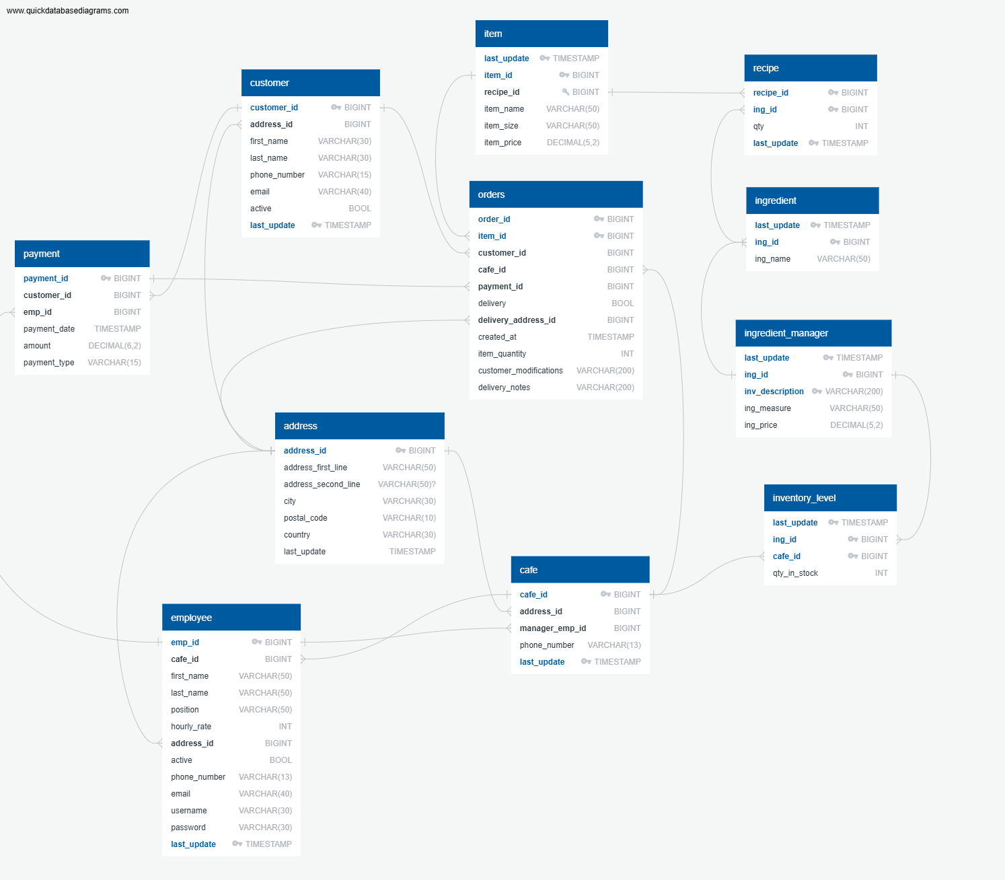

Example showing content of the data base. Snippet of “payment” table

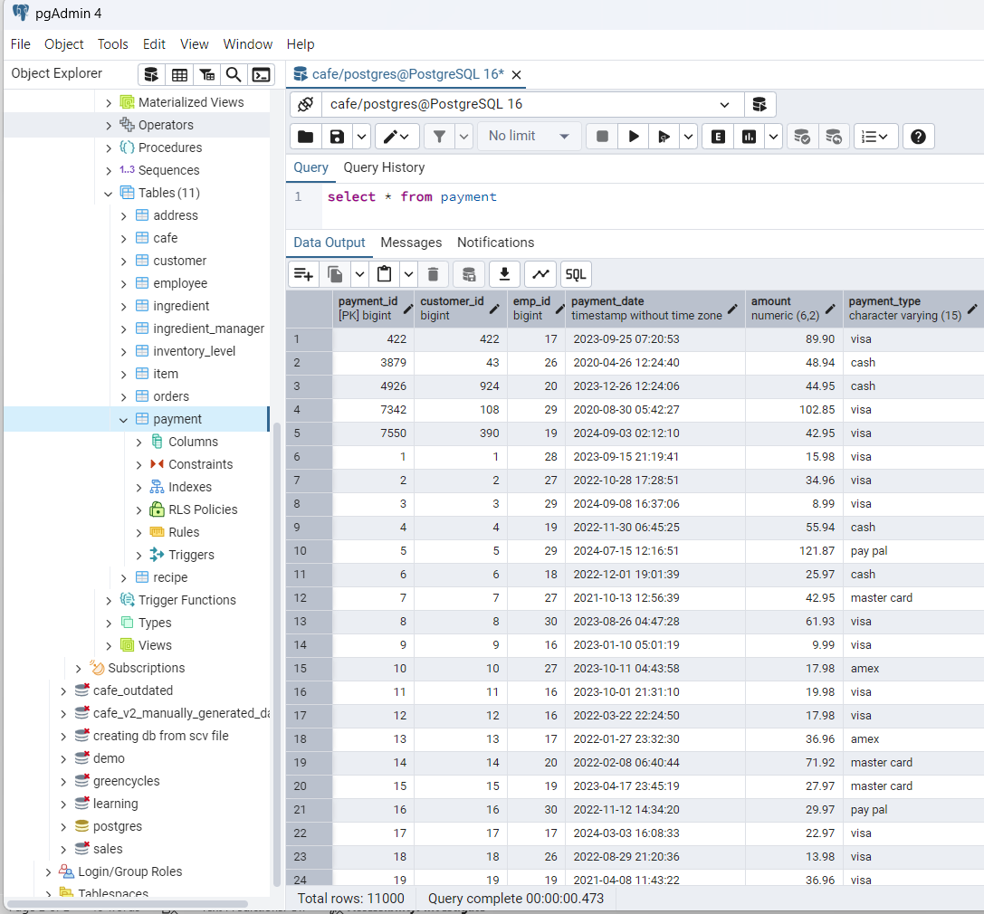

Extracting sales data from database in .csv format

Screenshot of one of the extracted tables:

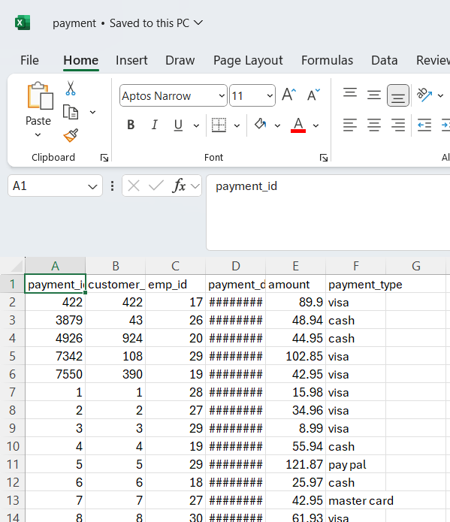

Part 2: Transforming and aggregating sales data using Python Pandas library

Snippet of the code that aggregates data:

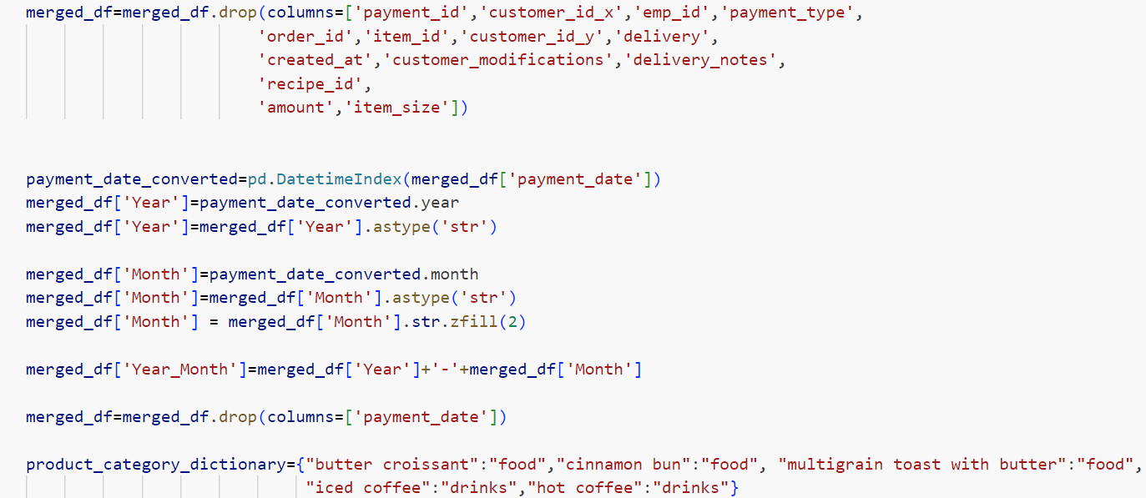

Screenshot of the output of the code (.csv file with aggregated data):

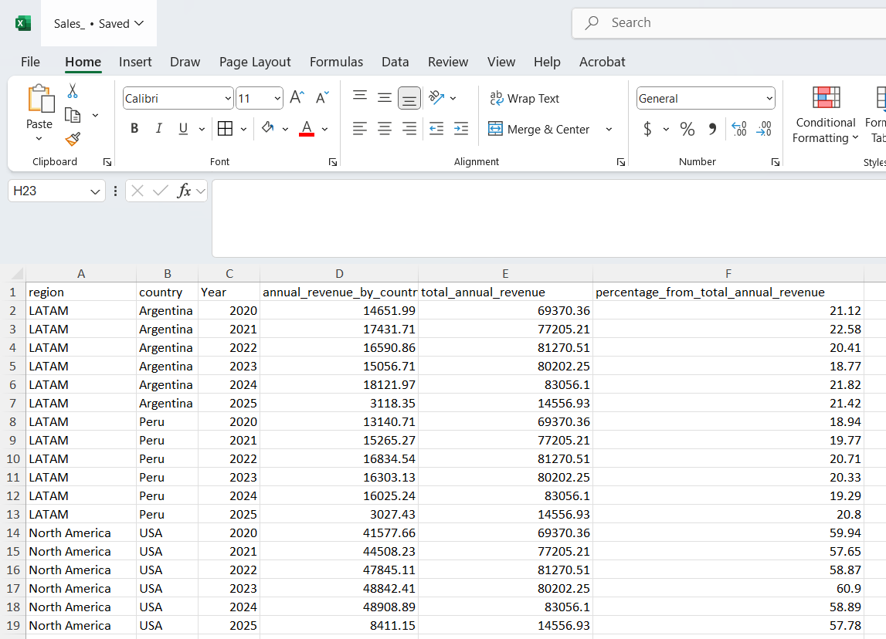

Part 3:Visualisations.Creating two dashboards in Tableau: first dashboard shows sales overview across regions and second offers sales comparison between products and between product categories.

The use of filters makes dashboards dynamic (user can utilize filters to display information for selected years):

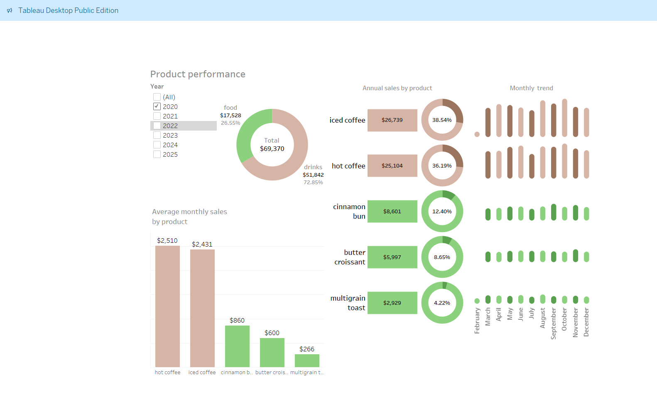

Dashboard with sales by geographic region shows comparison of annual sales between regions, between countries and between individual coffee shops as well as monthly sales in each country and chart that compares monthly sales of a particular coffee shop for the selected year with average monthly sales of this coffee shop.

